Ciena Interview Experience (Java Profile) Daya Shankar (MCA 2022-24)

There are total 4 rounds

1. OA

2. Technical Interview 1

3. Technical Interview 2

4. HR

Round 1: OA

Platform used - https://www.codility.com/

2 DSA Problems and some CS Fundamentals Question

Problem 1:

Similar to below image

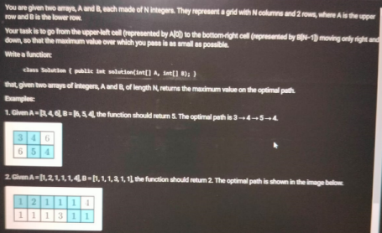

Problem 2:

Given an integer N, returns the smallest integer greater than N, the sum of whose digits is twice as big as the sum of digits of N.

Examples:

1. N = 14, the function should return 19.

2. N = 10, return 11.

3. N = 99, return 9999.

Round 2: TI1

Starting with the project

Discussion around my project (around 15 mins)

(Actually he is trying to get , i actually build the project or copied it)

Method Overloading vs Overriding with example?

4 OOPS pillar with real life example

Abstract classes vs Interfaces?

Does JAVA support Multiple inheritance (wait for my answer) and Why not?

Generics

● benefits

● write down a method which accepts only numbers types (formed by digits), and return the addition of intergers

Gave some random integers and asked , which sorting algo you used to sort these numbers and why?

Write down the Quick sort Algorithm?

Round 3: TI2

Introduce yourself

Tell me the all subject you have studied far in MCA

Have you implemented all data structures on their own?

me: yes

Write down the stack implementation?

In which DSA problems have you used Stack?

Me: Arrays, Tree, Graph

Tell me the problem statement of Array?

Me: Next greatest element

Discussion around the problem , why did you use stack?

Stack is used where more ?

Me: Call Stack (Internally by the program)

Gave some String Questions?

How String Stored in Java?

- Heap , String Pool

How do you compare two objects for their equality based on their data members? Why do your projects majorly build using python and javascript?

Gave some code snippets and asked for the output and errors (like- Method overloading) Multithreading in Java

Round 4: HR

Introduce yourself

tell me about your family and schooling

Why Ciena?

Have you worked in team culture

what difficulties you faced during team work

● team members and responsibilities

● what problems you faced during project

● Time management

When was your tough time and how do you recover from that?

What 3 things make you different from others?